-- User Table

CREATE TABLE User (

user_id INT AUTO_INCREMENT PRIMARY KEY,

username VARCHAR(50) NOT NULL UNIQUE,

password VARCHAR(255) NOT NULL,

role ENUM('Admin', 'Student') NOT NULL

);

-- Student Table

CREATE TABLE Student (

student_id INT AUTO_INCREMENT PRIMARY KEY,

user_id INT UNIQUE,

first_name VARCHAR(50) NOT NULL,

last_name VARCHAR(50) NOT NULL,

email VARCHAR(100),

dob DATE,

address VARCHAR(255),

phone_number VARCHAR(15),

FOREIGN KEY (user_id) REFERENCES User(user_id)

);

-- Test Table

CREATE TABLE Test (

test_id INT AUTO_INCREMENT PRIMARY KEY,

test_name VARCHAR(100) NOT NULL,

test_date DATE,

total_marks INT

);

-- Marks Table

CREATE TABLE Marks (

marks_id INT AUTO_INCREMENT PRIMARY KEY,

student_id INT,

test_id INT,

obtained_marks INT,

FOREIGN KEY (student_id) REFERENCES Student(student_id),

FOREIGN KEY (test_id) REFERENCES Test(test_id)

);

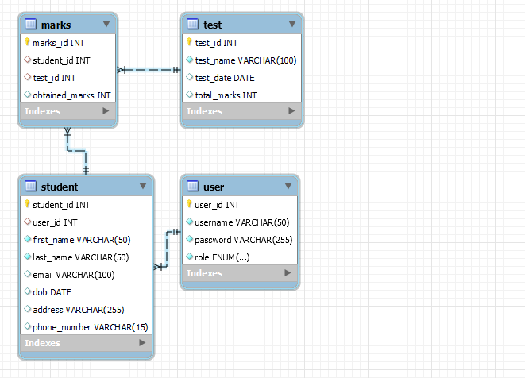

ASP .NET Models For Above tables

public class User

{

public int UserId { get; set; }

public string Username { get; set; }

public string Password { get; set; }

public UserRole Role { get; set; }

public List<Student> Students { get; set; }

}

public enum UserRole

{

Admin,

Student

}

public class Student

{

public int StudentId { get; set; }

public int UserId { get; set; }

public string FirstName { get; set; }

public string LastName { get; set; }

public string Email { get; set; }

public DateTime? Dob { get; set; }

public string Address { get; set; }

public string PhoneNumber { get; set; }

public User User { get; set; }

public List<Marks> Marks { get; set; }

}

public class Test

{

public int TestId { get; set; }

public string TestName { get; set; }

public DateTime? TestDate { get; set; }

public int TotalMarks { get; set; }

public List<Marks> Marks { get; set; }

}

public class Marks

{

public int MarksId { get; set; }

public int StudentId { get; set; }

public int TestId { get; set; }

public int ObtainedMarks { get; set; }

public Student Student { get; set; }

public Test Test { get; set; }

}

using Microsoft.EntityFrameworkCore;

public class SchoolDbContext : DbContext

{

public SchoolDbContext(DbContextOptions<SchoolDbContext> options) : base(options)

{

}

public DbSet<User> Users { get; set; }

public DbSet<Student> Students { get; set; }

public DbSet<Test> Tests { get; set; }

public DbSet<Marks> Marks { get; set; }

protected override void OnModelCreating(ModelBuilder modelBuilder)

{

modelBuilder.Entity<Student>()

.HasOne(s => s.User)

.WithOne()

.HasForeignKey<Student>(s => s.UserId);

modelBuilder.Entity<Marks>()

.HasOne(m => m.Student)

.WithMany(s => s.Marks)

.HasForeignKey(m => m.StudentId);

modelBuilder.Entity<Marks>()

.HasOne(m => m.Test)

.WithMany(t => t.Marks)

.HasForeignKey(m => m.TestId);

}

}